# SQL Scripts

2.1 SQL script to create the database structure in SQL server

CREATE TABLE Booking (

booking_number INTEGER NOT NULL IDENTITY,

event_id INTEGER NOT NULL,

status VARCHAR(20) NOT NULL,

datetime DATETIME NOT NULL,

booking_memo VARCHAR(50),

quantity INTEGER NOT NULL,

CONSTRAINT pk_Booking PRIMARY KEY(booking_number),

CONSTRAINT fk_Booking FOREIGN KEY(event_id) REFERENCES Event(event_id),

CONSTRAINT ck_Booking CHECK(status IN ('reserved', 'refunded', 'sold'))

);

CREATE TABLE Event (

event_id INTEGER NOT NULL IDENTITY,

ticket_price FLOAT NOT NULL,

status VARCHAR(20) NOT NULL,

start_date DATE NOT NULL,

end_date DATE NOT NULL,

type VARCHAR(50) NOT NULL,

name VARCHAR(50) NOT NULL,

venue_id INTEGER NOT NULL,

CONSTRAINT pk_Event PRIMARY KEY(event_id),

CONSTRAINT fk_Event FOREIGN KEY(venue_id) REFERENCES Venue(venue_id),

CONSTRAINT ck_Event CHECK(status IN ('cancelled', 'running'))

) ;

CREATE TABLE Artist (

artist_id INTEGER NOT NULL IDENTITY,

firstname VARCHAR(50) NOT NULL,

lastname VARCHAR(50),

country VARCHAR(50) NOT NULL,

phone_number VARCHAR(20) NOT NULL,

rider VARCHAR(200),

CONSTRAINT pk_Artist PRIMARY KEY(artist_id)

) ;

CREATE TABLE Venue (

venue_id INTEGER NOT NULL IDENTITY,

venue_name VARCHAR(50) NOT NULL,

seat_capacity INTEGER NOT NULL,

CONSTRAINT PK_Venue PRIMARY KEY(venue_id),

);

CREATE TABLE Event_Artist (

event_id INTEGER NOT NULL,

artist_id INTEGER NOT NULL,

CONSTRAINT pk_Event_Artist PRIMARY KEY(event_id, artist_id),

CONSTRAINT fk_Event_Artist_Event FOREIGN KEY(event_id) REFERENCES Event(event_id),

CONSTRAINT fk_Event_Artist_Artist FOREIGN KEY(artist_id) REFERENCES Artist(artist_id)

);

2.2 Database Diagram

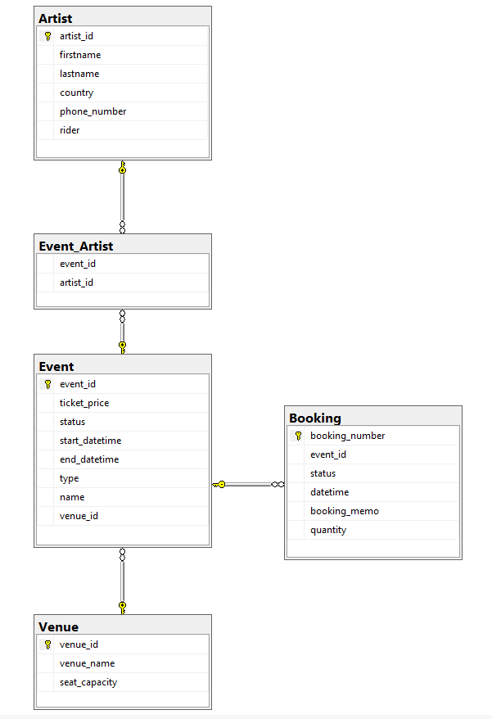

*Pic. 2. Database Diagram*

2.3 SQL script to create the indexes

The following indexes are automatically created by SQL Server: pk_Artist, pk_Booking, pk_Event, pk_Event_Artist, pk_Venue. Indexes to create are:

CREATE INDEX ix_event_artist_event ON Event_Artist(event_id);

CREATE INDEX ix_event_artist_artist ON Event_Artist(artist_id);   
CREATE INDEX ix_event_booking ON Booking(event_id);   
CREATE INDEX ix_event_venue ON Event(venue_id);

2.4 SQL script to populate the database with data for testing

Booking:

insert into Booking (event_id, status, datetime, booking_memo, quantity)

values ('1', 'reserved', '2018-12-11 15:20:00 ', '123456789', '2');

insert into Booking (event_id, status, datetime, booking_memo, quantity)

values ('2', 'refunded', '2018-12-12 14:10:12', NULL, '4');

insert into Booking (event_id, status, datetime, booking_memo, quantity)

values ('3', 'sold', '2018-12-10 12:15:00', '123456788', '5');

Event:

insert into Event (ticket_price, status, start_datetime, end_datetime, type, name, venue_id)

values ('120.50', 'running', '2019-01-11 12:00:00', '2019-01-12 17:00:00', 'ice-show', 'Plyuschenko and co', '1');

insert into Event (ticket_price, status, start_datetime, end_datetime, type, name, venue_id)

values ('78.00', 'running', '2019-01-02 15:00:00', '2019-01-02 18:00:00', 'concert', 'Britney Spears Show', '1');

insert into Event (ticket_price, status, start_datetime, end_datetime, type, name, venue_id)

values ('12.50', 'cancelled', '2019-02-11 12:00:00', '2019-02-11 15:00:00', 'movie', 'Smth about love', '2');

insert into Event (ticket_price, status, start_datetime, end_datetime, type, name, venue_id)

values ('60.50', 'cancelled', '2019-02-11 12:00:00', '2019-02-11 15:00:00', 'con-cert', 'Suomi maa', '2');

insert into Event (ticket_price, status, start_datetime, end_datetime, type, name, venue_id)

values ('45.50', 'running', '2018-06-30 13:00:00', '2018-07-11 16:30:00', 'dance', 'Finnish summer', '1');

insert into Event (ticket_price, status, start_datetime, end_datetime, type, name, venue_id)

values ('15.50', 'running', '2018-12-10 13:00:00', '2018-12-20 16:30:00', 'con-cert', 'Rock today', '2');

Venue:

insert into Venue (venue_name, seat_capacity)

values ('Grand Arena', '3500');

insert into Venue (venue_name, seat_capacity)

values ('Small Arena', '70');

Artist:

insert into Artist (firstname, lastname, country, phone_number, rider)

values ('Britney', 'Spears', 'USA', '1234566', 'Valio milk, Paulig coffee, Fazer chocolate, white roses');

insert into Artist (firstname, lastname, country, phone_number, rider)

values ('John', 'Travolta', 'USA', '1234568', NULL);

insert into Artist (firstname, lastname, country, phone_number, rider)

values ('Evgeny', 'Plyuschenko', 'Russia', '1237568', 'Valio milk, Paulig coffee, Fazer chocolate, karelian pies');

insert into Artist (firstname, lastname, country, phone_number, rider)

values ('Adele', 'Winston', 'UK', '74574743', 'Indian tea, Karellian pirakka, allergy to any flowers');

insert into Artist (firstname, lastname, country, phone_number, rider)

values ('Saara', 'Aalto', 'Finland', '4543536', 'Irish coffee, fruits, roses');

insert into Artist (firstname, lastname, country, phone_number, rider)

values ('Jorma', ' Uotinen', 'Finland', '9768567', 'coffee, meet balls, any flowers');

insert into Artist (firstname, lastname, country, phone_number, rider)

values ('ZZ Top', NULL, 'USA', '546547', NULL);

Event_Artist:

insert into Event_Artist (event_id, artist_id)

values (2, 1);

insert into Event_Artist (event_id, artist_id)

values (1, 3);

insert into Event_Artist (event_id, artist_id)

values (4, 5);

insert into Event_Artist (event_id, artist_id)

values (5, 6);

insert into Event_Artist (event_id, artist_id)

values (6, 7);

--checking constraints out--

insert into Booking (event_id, status, datetime, booking_memo, ticket_number)

values ('1', 'hello', '2018-12-11 13:00:00', '123456789', '123');

insert into Event (ticket_price, status, start_datetime, end_datetime, type, name, venue_id)

values ('120.50', 'hello', '2019-01-11', '2019-01-11', 'ice-show', 'Plyuschenko and co', '1');

2.5 SQL script to test the database

--1.

UPDATE Booking

SET status = 'reserved'

WHERE booking_number = 7

--2.

UPDATE Booking

SET status = 'refunded'

WHERE booking_number = 7

--3.

UPDATE Booking

SET quantity = 6

WHERE booking_number = 8

--4.

UPDATE Booking

SET status = 'sold'

WHERE booking_number = 7

--5.

DELETE FROM Booking

WHERE status = 'reserved' AND DATEDIFF(DAY, datetime, GETDATE()) >= 3

--6.

DELETE Booking FROM Booking

JOIN Event ON (Event.event_id = Booking.event_id)

WHERE Booking.status NOT LIKE 'sold' AND Event.end_datetime < (SELECT GETDATE())

--7.

UPDATE Event

SET status = 'cancelled'

WHERE event_id = 1

--8.

UPDATE Booking

SET status = 'refunded'

WHERE event_id IN (SELECT event_id FROM Event WHERE status = 'cancelled')

--9.

SELECT name FROM Event

WHERE DATENAME(MONTH, start_datetime) = 'January'

--10.

SELECT name FROM Event

WHERE DATENAME(MONTH, start_datetime) = 'January' AND type = 'theater'

--11.

SELECT phone_number FROM Artist

WHERE firstname = 'Adele'

--12.

SELECT firstname, lastname, rider, Event.start_datetime FROM Artist

JOIN Event_Artist ON (Artist.artist_id = Event_Artist.artist_id)

JOIN Event ON (Event.event_id = Event_Artist.event_id)

WHERE lastname = 'Aalto' AND firstname = 'Saara'

--13.

SELECT SUM(quantity) FROM Booking

JOIN Event ON (Event.event_id = Booking.event_id)

JOIN Event_Artist ON (Booking.event_id = Event_Artist.event_id)

JOIN Artist ON (Artist.artist_id = Event_Artist.artist_id)

WHERE Artist.lastname = 'Uotinen' AND Artist.firstname = 'Jorma' AND Event.name = 'Finnish summer' AND Event.start_datetime = '2018-06-30' AND type = 'dance'

--14.

SELECT (Venue.seat_capacity - Booking.quantity) FROM Booking

JOIN Event ON (Event.event_id = Booking.event_id)

JOIN Event_Artist ON (Booking.event_id = Event_Artist.event_id)

JOIN Artist ON (Artist.artist_id = Event_Artist.artist_id)

JOIN Venue ON (Event.venue_id = Venue.venue_id)

WHERE firstname = 'ZZ Top' AND Event.type = 'con-cert' AND Event.start_datetime = '2018-12-10'

--15.

SELECT SUM(ticket_price*quantity) FROM Event

JOIN Booking ON (Booking.event_id = Event.event_id)

WHERE YEAR(datetime) = YEAR(GETDATE())